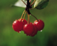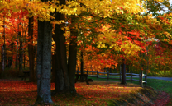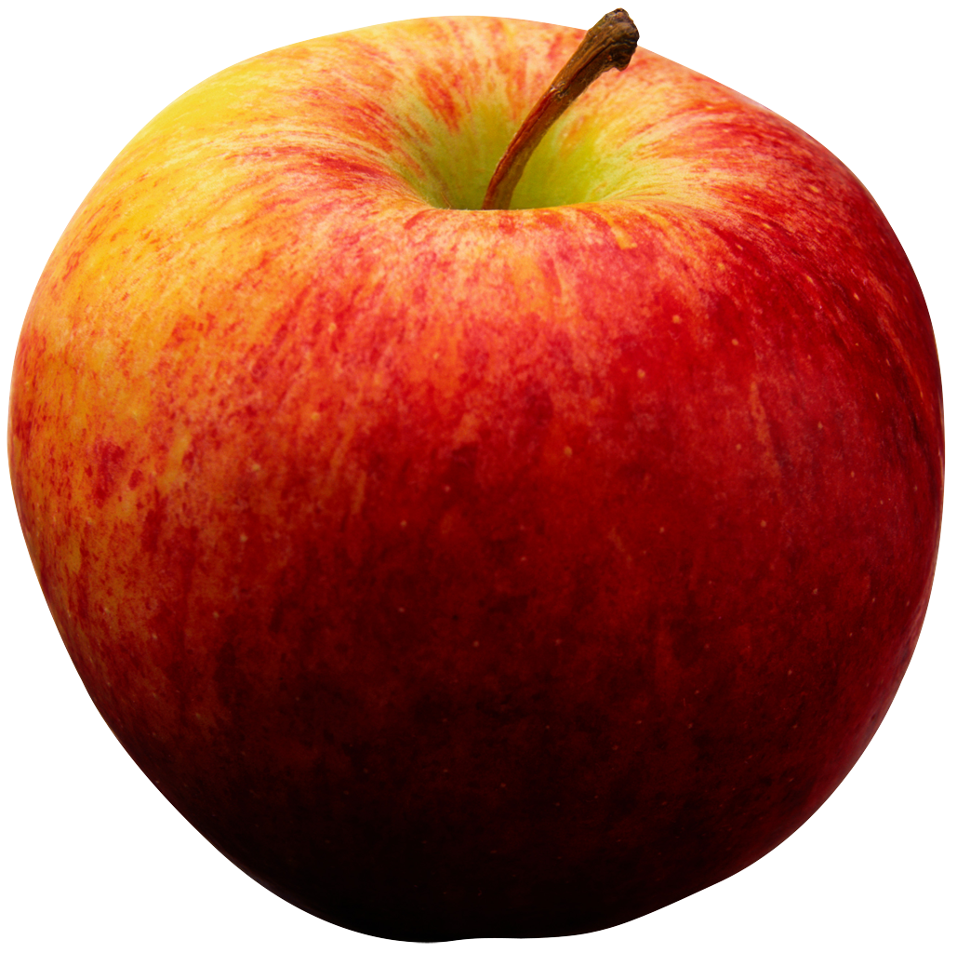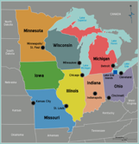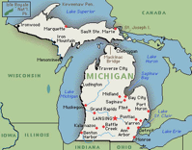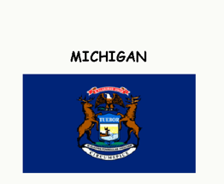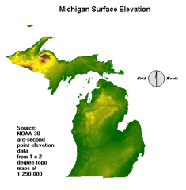

Capital: Lansing

Nickname: The Great Lakes State

State flower: Apple Blossom

State tree: White Pine

State bird: American Robin

Famous people: Henry Ford, Madonna, and Gerald R. Ford

Pick Michigan as the new nation’s capital!

### By: Ms. Carman

### 4th grade 2011

🙞 🙜

Read more to find the reasons why . .

Highlights of this region include:

* All four seasons.
* The elevation is flatter than other parts of the country so crops can be grown.
* There are lots of ways to get around since there are the Great Lakes, railways, and this area is home to the car.
* There are large cities such as Chicago and Detroit.

#### Michigan is in the Middle West Region.

# Why here?

## Other fun facts about Michigan:

**Frankenmuth**

Here you can go to a Christmas Store that is open 365 days of the year. The place was founded by Germans and is famous for chicken dinners, fudge and the downtown.

**Mackinaw Island**

You have to travel across the Mackinaw Bridge from the Lower Peninsula to the Upper Peninsula and take a boat to get to this island. There are no cars allowed but you can travel by horse and bike.

**Sleeping Bear Dunes**

These natural sand dunes are off Lake Michigan and offer a great sight to the lake.

**Elevation**

Michigan does not have extreme high or low elevation, so this makes it easy to travel in a car on the roads.

**Climate**

Michigan has all four seasons throughout the year. The winters are chilly, but if you enjoy winter sports there are plenty to take part in. You can ski, sled, snowboard, and ice skate. Even if you don’t like snow, you can stay in and drink hot chocolate. Spring is filled with lots of rain and blossoming flowers. Summers you can enjoy the Great Lakes by going to the beach and swimming. Falls has beautiful colors as many trees lose their leaves. Apples are crisp and the donuts are yummy!

**Population**

Whether you enjoy the big cities of Detroit or Grand Rapids or the smaller town of Ortonville, there is a place for you. Lansing is the capital and is located in the middle of the state. The largest city is Detroit with 9,863,775 people. There is less population density in the Upper Peninsula than the Lower Peninsula.

**Other**

* Five Great Lakes
* Mackinaw Bridge
* The home of Motown
* Two Peninsulas
* Fresh cherries and apples
* Just south of the country Canada

# What makes Michigan so special?

## Places to visit